How to use the Lin Kvaser driver in Busmaster

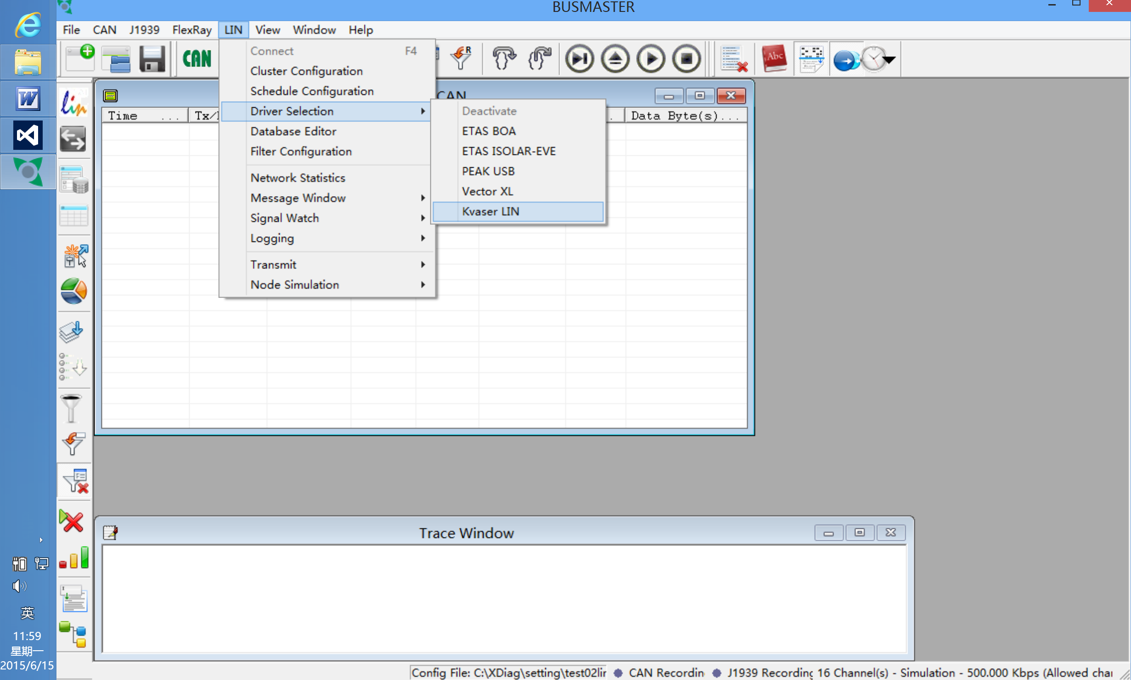

1. Copy "LIN_Kvaser" into the "Sources" Directory.
2. In VSExpress 2012's Soluiton Explorer,add existed project.Select the LIN_Kvaser project and add it.
3. Add project "LIN_Kvaser" into project "DIL_Interface"'s reference.
4. Modify "DIL_Datatypes.h" in project "DataTypes" (Red part)
enum
{
DRIVER_LIN_ISOLAR_EVE_VLIN = 0,
DRIVER_LIN_VECTOR_XL,
DRIVER_LIN_ETAS_BOA,
DRIVER_LIN_PEAK_USB,
DRIVER_LIN_KVASER,
DIL_LIN_TOTAL,
DAL_LIN_NONE = ~0x0
};

5. Modify "DIL_LIN.cpp" in project "DIL_Interface" (Red part)
static ENTRY_DIL sg_ListDIL[] =
{
// Added Short cut keys
/* simulation should be the first entry... */
{DAL_LIN_NONE, "&Deactivate"},
{DRIVER_LIN_ETAS_BOA, "ETAS &BOA"},
{DRIVER_LIN_ISOLAR_EVE_VLIN,"ETAS &ISOLAR-EVE"},
{DRIVER_LIN_PEAK_USB,"&PEAK USB"},
{DRIVER_LIN_VECTOR_XL, "&Vector XL"},
{DRIVER_LIN_KVASER, "&Kvaser LIN"},
};

HRESULT CDIL_LIN::DILL_SelectDriver(DWORD dwDriverID, HWND hWndOwner,
Base_WrapperErrorLogger* pILog)
{
USES_CONVERSION;

HRESULT hResult = S_FALSE;

if (DILL_GetSelectedDriver() == dwDriverID)
{
hResult = DAL_ALREADY_SELECTED;
}
else if (pILog == nullptr)
{
hResult = ERRLGR_INVALID;
}
else
{
if (hWndOwner == nullptr)
{
/* Log a warning message informing about the invalidity of the
owner window handle. */
}

//Save the currently selected DIL library handle
if ( m_hDll )
{
DILL_PerformClosureOperations();
FreeLibrary(m_hDll);
delete m_pBaseDILLIN_Controller;
m_pBaseDILLIN_Controller = nullptr;
m_hDll = nullptr;
m_hOldDll = m_hDll;
m_pOldBaseDILLIN_Controller = m_pBaseDILLIN_Controller;
m_dwOldDriverID = m_dwDriverID;
m_hDll = nullptr;
}

switch(dwDriverID)
{

case DRIVER_LIN_ISOLAR_EVE_VLIN:
m_hDll = LoadLibrary("LIN_ISOLAR_EVE_VLIN.dll");
break;

/* case DRIVER_LIN_DEACTIVATE_VLIN:
if (m_hDll == nullptr)
{
hResult = DAL_INVALID;
FreeLibrary(m_hDll);
m_dwDriverID = DAL_NONE;
}
else
{
hResult = ERR_LOAD_DRIVER;
pILog->vLogAMessage(A2T(__FILE__), __LINE__, _("LIN not Active..."));
}
return hResult;*/
case DRIVER_LIN_VECTOR_XL:
m_hDll = LoadLibrary("LIN_Vector_XL.dll");
break;
case DRIVER_LIN_ETAS_BOA:
m_hDll = LoadLibrary("LIN_ETAS_BOA.dll");
break;
case DRIVER_LIN_PEAK_USB:
m_hDll = LoadLibrary("LIN_PEAK_USB.dll");
break;
case DRIVER_LIN_KVASER:
m_hDll = LoadLibrary("LIN_Kvaser.dll");
break;
default:
DILL_PerformClosureOperations();
vSelectInterface_Dummy();
m_dwDriverID = DAL_NONE;
return hResult;
}

6. Make sure linlib.dll, canlib32.dll is in your Executable Directory(BIN\Release).
7. Please contact this email address if any questions find.

Email : lin@uincore.net

